**SCP: Site-33**

Game Design Document

Piotr Koziol Gameplay and Game Design (MCM433)

# Contents

1. Contents 2

2. Overview 3

2.1. Summary 3

2.2. Key Features 3

2.3. Genre 3

3. Story 3

4. Visual Style 4

4.1. Aesthetics / Theme 4

4.1.1. Inspirations from games set in the SCP universe 4

4.2. UI 5

4.2.1. Main Menu 5

4.2.2. Settings 6

4.2.3. HUD 6

5. Gameplay Systems 7

5.1. Default Controls 7

5.2. Interaction System 7

5.3. Inventory System 7

5.4. Thematic Mechanic 7

5.5. Puzzles 8

5.5.1. Light Containment Zone 8

5.5.2. Heavy Containment Zone 9

5.5.3. Entrance Zone 12

6. Level Design 13

6.1. Overview 13

6.2. Light Containment Zone 14

6.3. Heavy Containment Zone 15

6.4. Entrance Zone 16

7. Audio 17

7.1. Music 17

7.2. Sound Effects 17

8. References 17

# Overview

## Summary

SCP: Site-33 is a single player puzzle game where the player must escape a facility housing anomalies during a containment breach of said anomalies.

## Key Features

The game has several features with the main overarching mechanic being collecting keycards to progress through the facility which is the main way to escape the facility. The method of obtaining the keycards is completing puzzles thus the game requires these features:

* A movement system
* An interaction system
* A range of puzzles
* An inventory system

## Genre

The game is a psychological horror puzzle game where throughout most of the game, there is a perceived threat to make the player on edge while completing puzzles without there being an actual threat.

# Story

The game takes place in a facility managed by the SCP Foundation where a containment breach has taken place in. during the containment breach, several shockwaves were induced which caused structural damage to the facility causing hallways to collapse leaving only 1 way out for the player. The player is a class D personnel, which are practically lab rats for the SCP Foundation used for testing interactions with SCPs often leading to their deaths. The starts after the worse of the breach has occurred but the SCP foundation’s mobile task force has not yet arrived and the cell door malfunctioned, causing the door to be open allowing the player to try to escape the facility

# Visual Style

## Aesthetics / Theme

The game will have a semi realistic art style being set in a research facility which would help with the psychological horror aesthetic of the game. The player will be in an isolated facility where most of the personnel are dead. The facility is meant to look monochrome and washed out with the colours of the walls and textures which helps convey the grim theme of the game.

### Inspirations from games set in the SCP universe

SCP: 5K (formerly SCP: Pandemic)

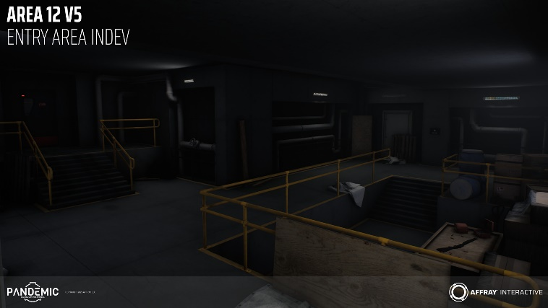

SCP: Secret Laboratory

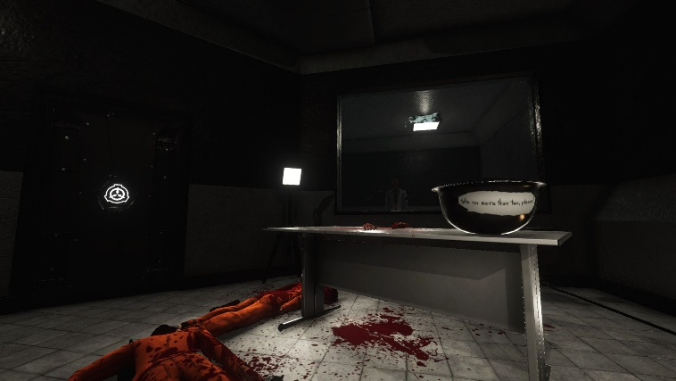

SCP: Containment Breach

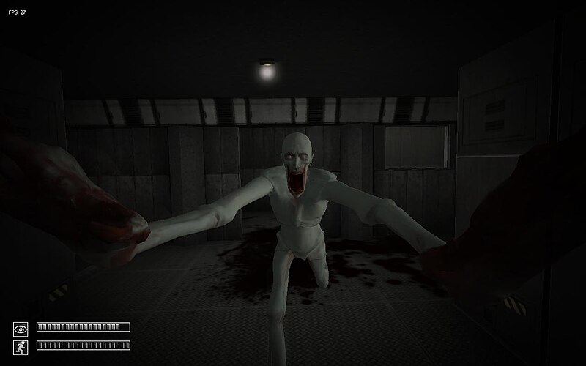

## UI

### Main Menu

The main menu will only consist of 4 buttons, a play button to play the game, a settings button to configure various settings, a credits button to credit asset authors and a quit button to quit the game. The menu will also consist of the game’s name and dynamic background art which shows parts of the game.

Mock-up of the Main Menu:

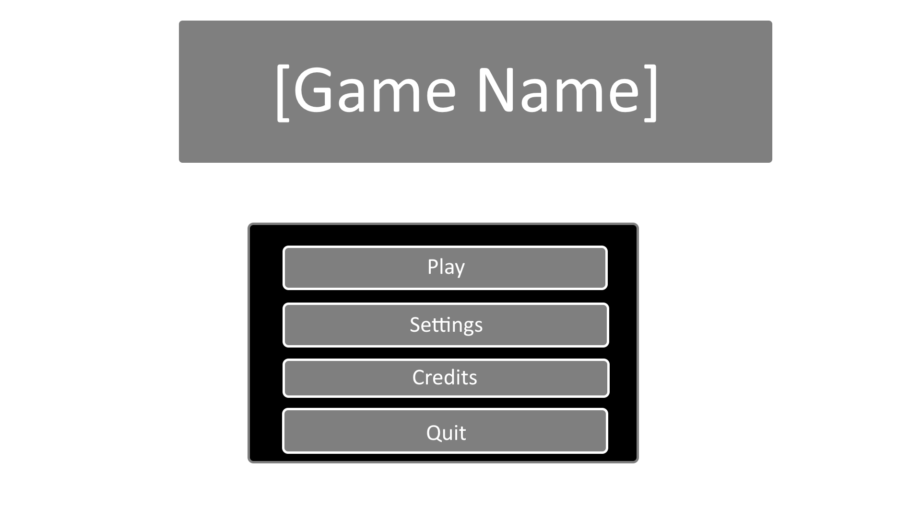

### Settings

The settings menu will consist of 4 tabs, a gameplay tab to adjust the gameplay, a video tab to adjust the resolution, a graphics tab to adjust the graphics and an audio tab to adjust the audio.

Mock-up of the settings menu:

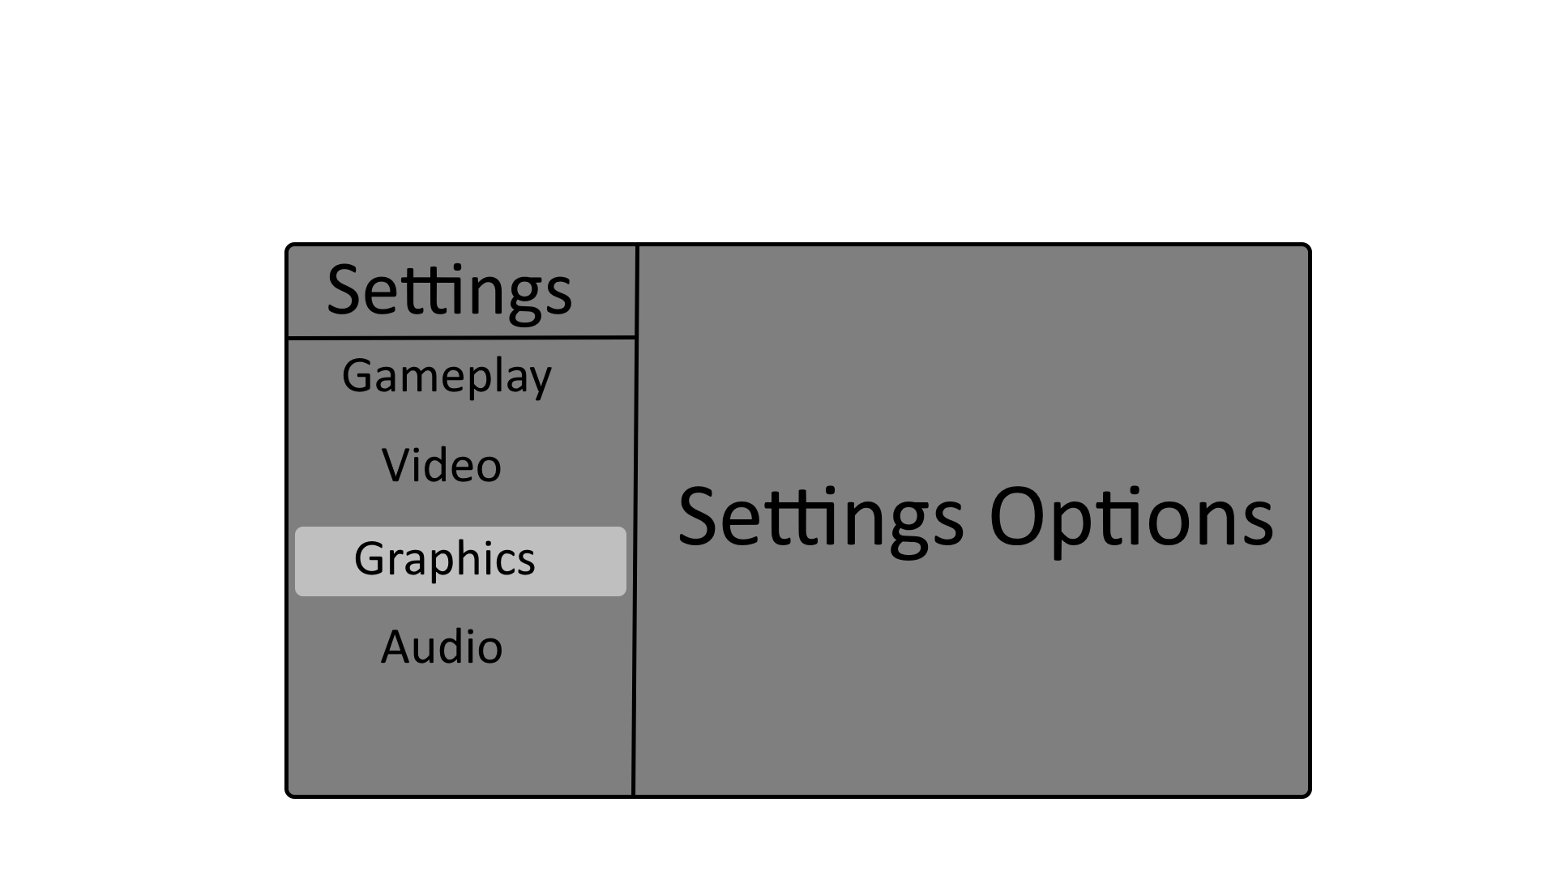

### HUD

The HUD for the game will be minimal Featuring only an Inventory bar with an outline for the current item equipped, a centre dot and an interaction tooltip to show what button to press to interact with an object.

Mock-up of the player HUD:

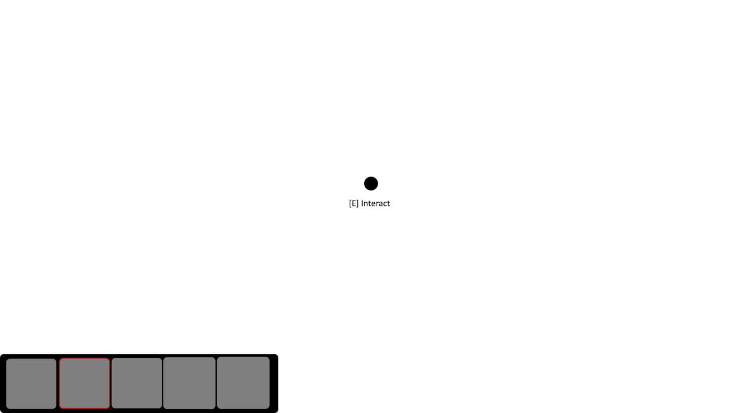

# Gameplay Systems

## Default Controls

|  |  |
| --- | --- |
| Action | Key bind |
| Movement | W, A, S, D |
| Interact | E |
| Blink | Space |
| Pause Menu / Leave Interactable | Esc |

## Interaction System

The interaction works by constantly performing a raycast facing forward of the camera direction and checking if the object the raycast hit is marked as an interactable in which then, a tooltip will pop up stating that the player can interact with the object and pressing the interact key bind when the play is looking at the object will interact with it.

## Inventory System

The game will have a simple inventory system which is displayed on the bottom left corner of the screen with a set number of slots. Items collected are used for completing puzzles such as a getting a keycard to progress to next puzzles

## Thematic Mechanic

The game has two thematic mechanics, the main one being the process of collecting keycards to progress to the next zone in the facility till the player can escape, such as a scientist keycard can open the checkpoint to the Heavy Containment Zone and the Facility Manager can open the Gate A exit. The other thematic mechanic is the blinking system which is used in the SCP-173 encounter in the 3rd puzzle as the SCP in lore can only move when the SCP is not within line of sight of any person even through security cameras which also occurs when a person blinks causing the SCP to move.

## Puzzles

### Light Containment Zone

Puzzle Design Diagram:

#### Obtaining the Scientist Keycard

Upon entering the puzzle room, there will be a combination safe which houses SCP-005 (Skeleton Key) which can be used to unlock any key lock. SCP-005 is used to unlock a key safe which houses a Scientist keycard Within the room. The combination of the safe is randomised and the player must slowly turn the dial to the right which will shake more and more till it reaches the first combination, once the first combination is hit, and audible sound is heard and then this must be repeated with turning left and one more time turning right. In addition to this there will be a document next to the combination safe saying that the SCP is housed within it and a document next to the key safe stating that a scientist left it in there as a spare keycard.

Room Mock-up:

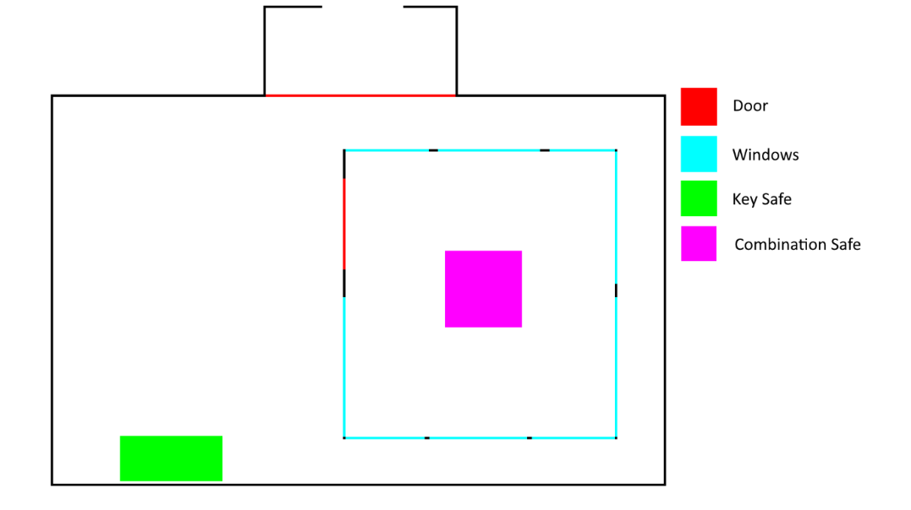

### Heavy Containment Zone

Puzzle Design Diagram:

#### Unlock the general Testing Chamber

Upon entering the puzzle room, there will be a corpse with a document containing logs of testing where in the document it will state that a Major Scientist Keycard was lost during testing which was not reclaimed however to access the general testing chamber, the player must restore power to the testing area. To do this, the player must find a fuse to a Fusebox and insert the fuse, connect corresponding wires to their corresponding ends in a wire box, adjust the voltage of the power to the correct voltage within the voltage controller and turn on the circuit breaker. If the player decides to turn on the circuit breaker and then work on the fuse and wires, it will electrocute and kill the player. Upon completing the puzzle, the spotlights will turn on and the doors will open along with CCTV turning on, showing the testing chamber and SCP-173.

Room Mock-up:

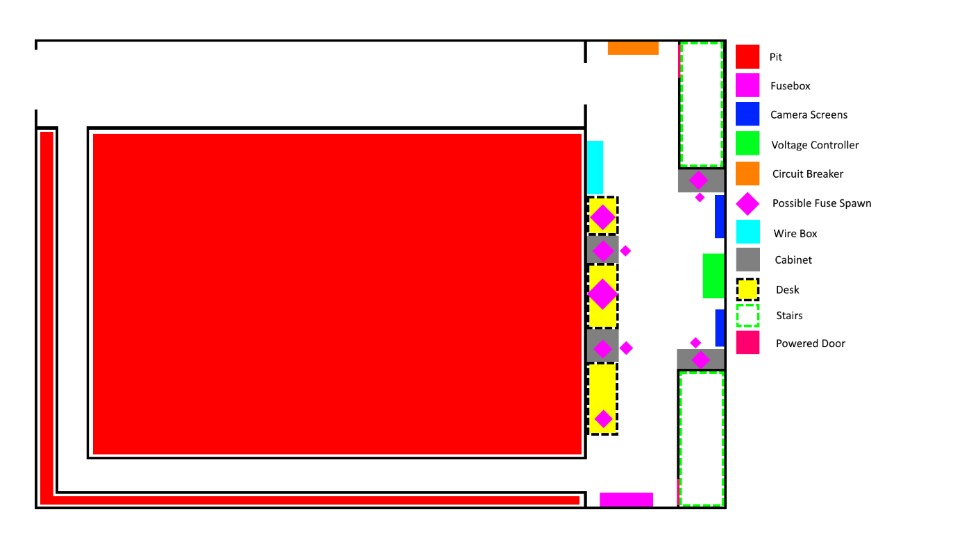

#### Obtaining the Major Scientist Keycard

Before the puzzle, there will be an interactable document on a corpse which will outline what SCP-173 is and the mechanics behind the SCP. When the player enters the puzzle room, there will be an airlock into the room which will have SCP-173 inside, the airlock is used to keep the SCP-173 inside the room to prevent interference in later puzzles. The player will have a blink bar which will cause the player to blink when the bar hits 0 or the player hits the blink key, afterwards the blink bar resets back to full. Whenever the player does not have line of sight of SCP-173, the SCP will move towards the player, when the SCP reaches the player when the player blinks, it will kill the player. The player must collect the keycard which is placed randomly within the testing chamber while avoiding getting killed by the SCP and leaving the room safely to complete the puzzle.

Room Mock-up:

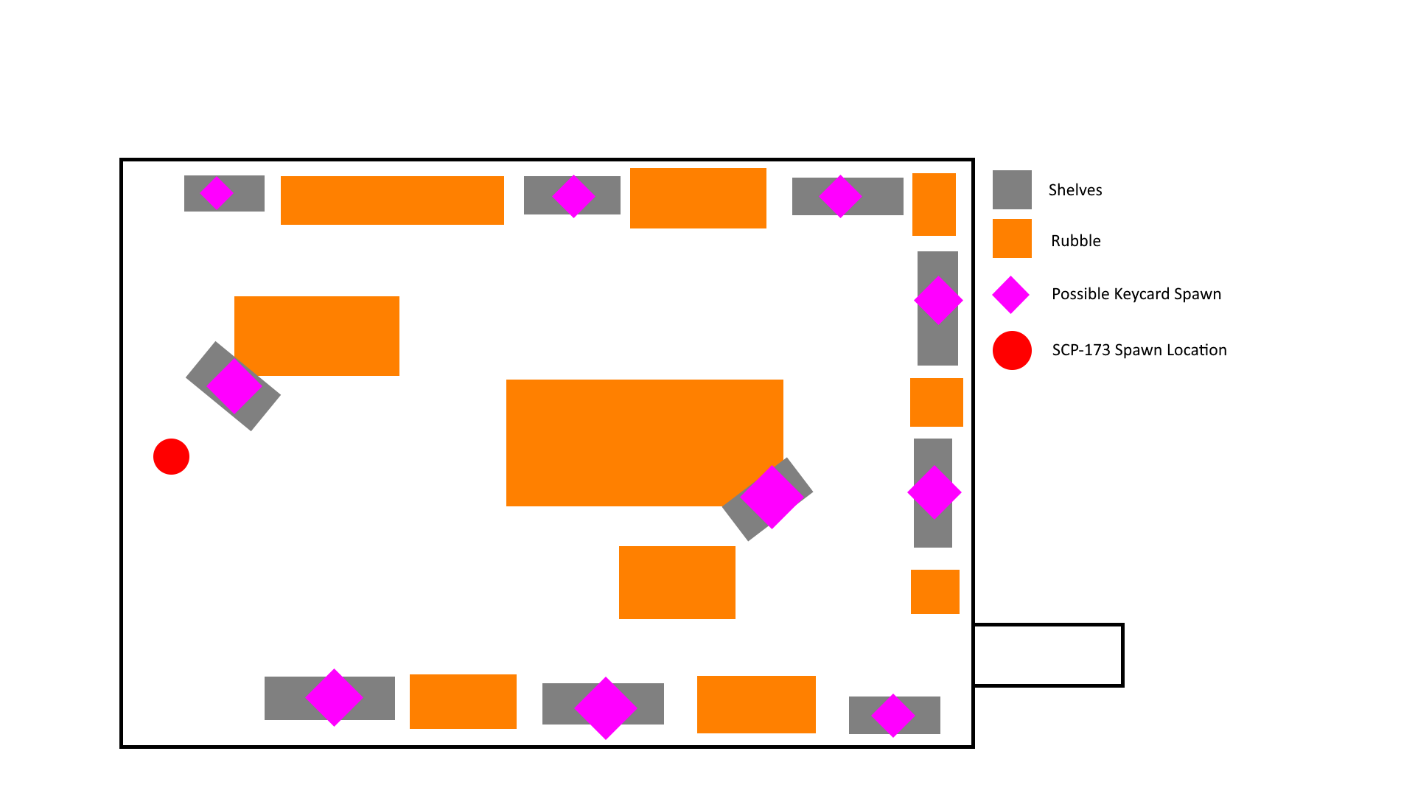

##### SCP-173 AI

Since SCP-173 only moves and attacks when out of line of sight or blinking, the dot / scalar product is used to calculate how similar the vector direction is between the normalised forward facing vector of the camera and the normalised vector from the player to the SCP which gives a value between -1 and 1 where 1 is directly facing, 0 is at a right angle and -1 is opposite directions which can be used with the addition of a ray cast from the player to the SCP to see if there aren’t any obstacles in the way. If the player does not have line of sight through this then the SCP will move towards the player or if the player is blinking. Once the player is in the kill range of the SCP and the SCP can move, it will kill the player.

Visualisation:

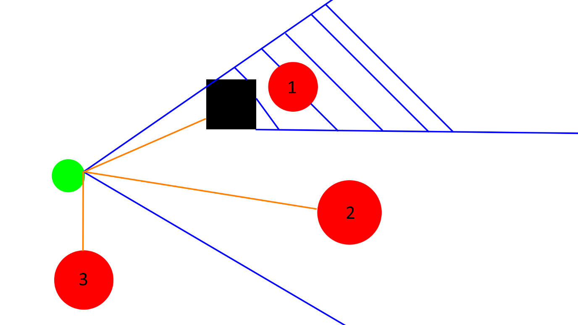

For the first example, marked 1, it is in the field of view but the raycast cannot hit the target, for example 2, marked 2, it is in the field of view and the raycast can hit it and for the last example, the raycast can hit but isn’t in the field of view.

##### Blinking System

The player will only start to blink once they are in a blinking zone which is an area where the blink system is active, which shows a blink bar on the player’s HUD and the player will blink after a certain amount of time or if the player chooses to blink with a key bind which will then have then blink for a set time and then reset the blink bar.

### Entrance Zone

Puzzle Design Diagram:

#### Obtaining the Facility manager Keycard

Inside the room, there will be server racks with displays on them, the goal is to have all the displays powered on by interacting with the racks, however enabling on rack, disables and or enables other racks in the room. If the player wants to reset the puzzle there will be a server restart switch which will restart the puzzle. There is also a display to display all the server racks which are turned on or off. Once the puzzle is solved, the door to the computer terminal and the facility manager keycard will be open.

Room Mock-up:

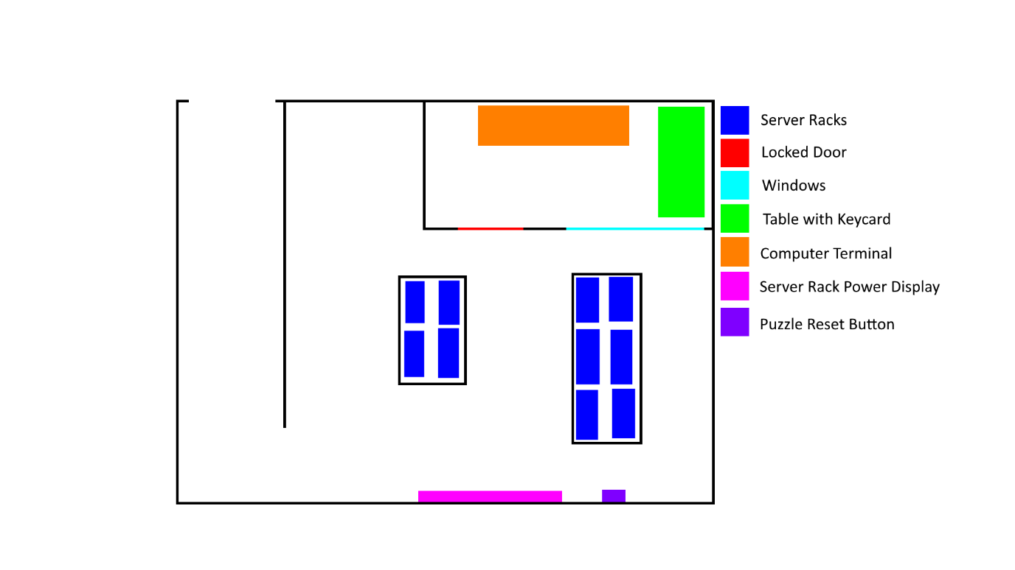

#### Lifting the gate A lockdown

Inside the room, there will be a computer terminal which has access to emails from foundation personnel in which several of the emails will contain parts of the code required to lift the lockdown on Gate A. on the same terminal there will be an application which brings up a digital keypad to unlock the gate. If the code is entered incorrectly 3 times, a memetic kill agent will appear on screen which will kill the player. If the code is entered correctly, it will lift the lockdown on gate A.

Mock-up of the computer terminal:

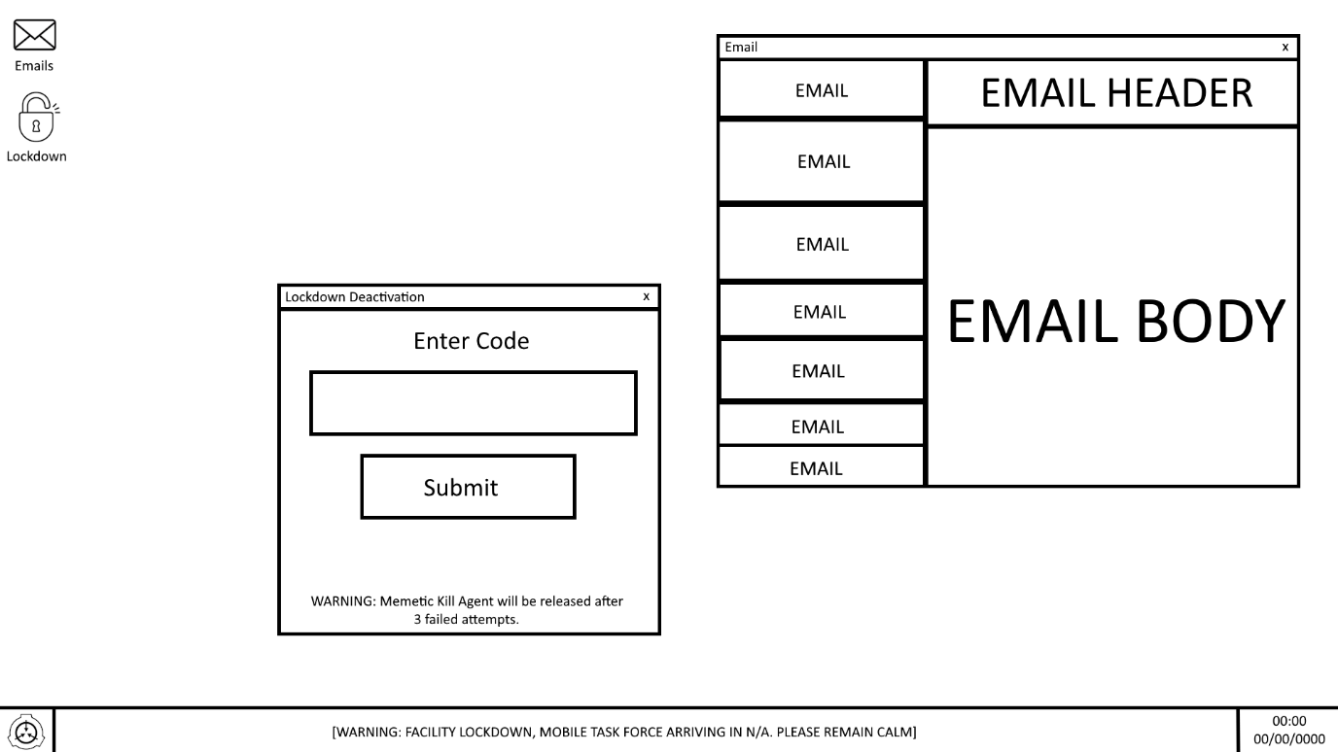

# Level Design

## Overview

The map is split up into 3 distinct zones, the Light containment zone, the heavy containment zone and the entrance zone, all of which have a different theme such as an office theme of industrial theme. The map is rather small, having areas blocked off by rubble due to structural collapses but in the lore the facilities are much bigger but helps the game remain in a realistic scope. To match the theme, the rooms are dimly lit and there is a fog obscuring objects from a further distance.

## Light Containment Zone

The light containment zone is a monochrome, sterile looking area which houses easy to contain SCPs such as Object SCPs like SCP-005 the skeleton key, locked up in a safe. One of the scientists has a spare scientist keycard in the SCP room locked in a safe where the original key has been lost.

Image of the Light Containment Zone:

Layout of the Light Containment Zone:

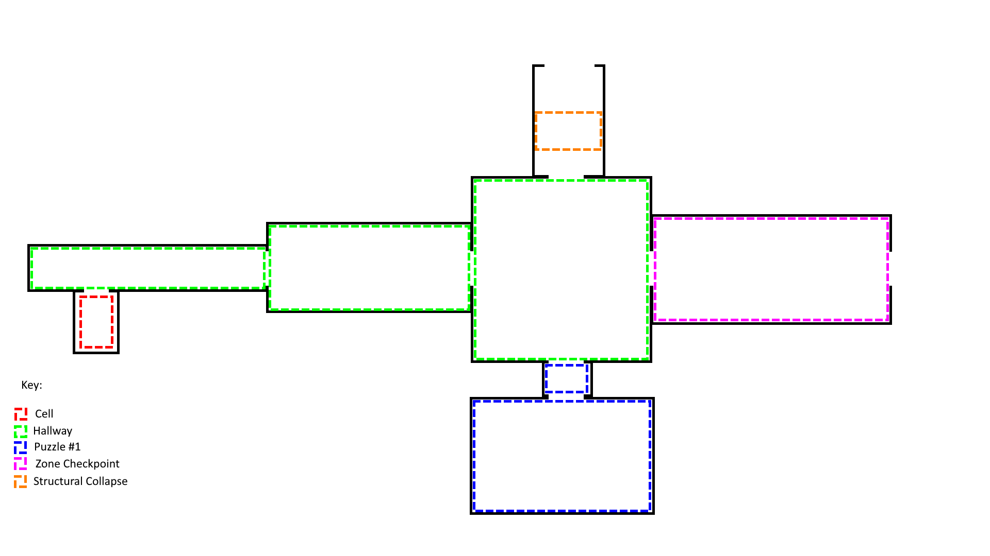

## Heavy Containment Zone

The heavy containment zone is an industrial looking zone which houses more difficult to contain SCPs, The zone houses the general testing Chamber which scientists used to test interactions with SCPs on-site with Class-D Personnel or other SCPs and before the containment breach they were testing SCP-173 which killed a scientist with a keycard however during the breach, the power to the general testing chamber went out due to panic, sealing the general testing chamber off.

Image of the Heavy Containment Zone:

Layout of the Heavy Containment Zone:

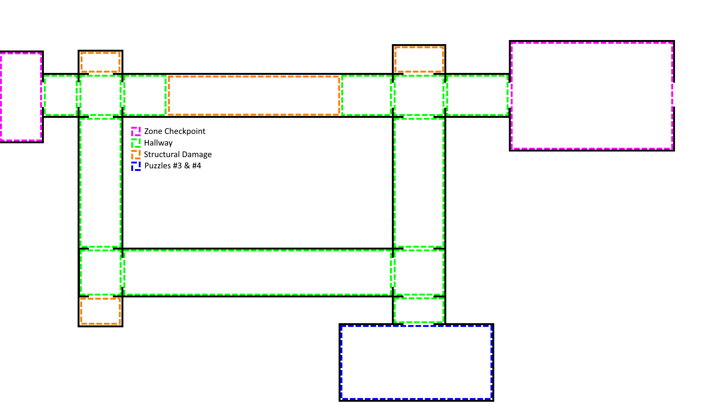

## Entrance Zone

The entrance zone is an office looking zone which houses most of the offices in the facility for management and scientists and contains the exit to the facility Gate A and the security room. During the breach a gate lockdown was initiated which led to Gate A being locked down.

Image of the Entrance Zone:

Layout of the Entrance Zone:

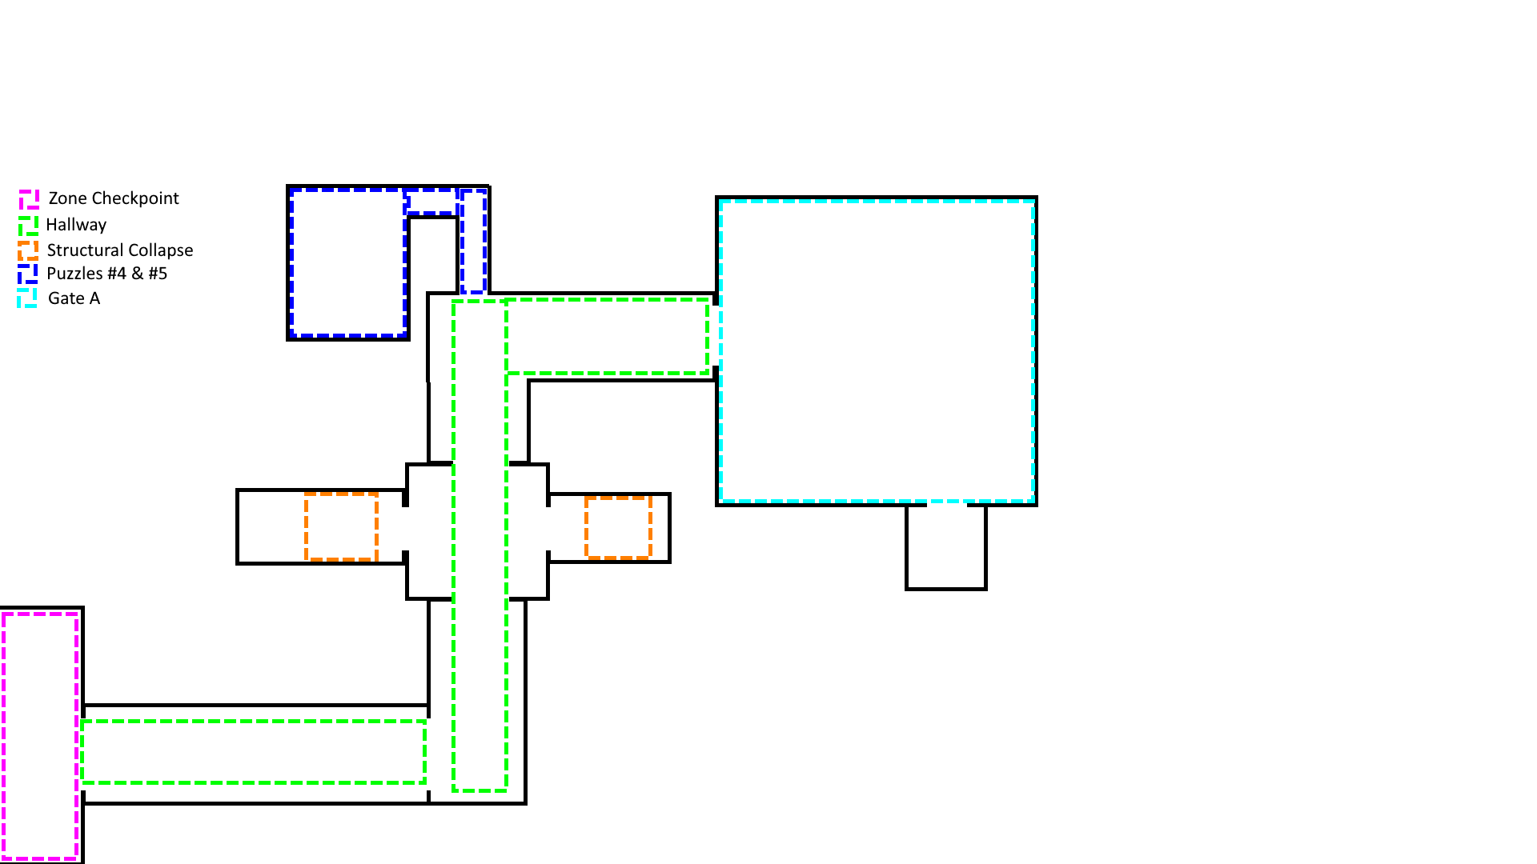

# Audio

## Music

The music in the game is meant to be subtle and eerie which build suspense in the player that something is out there and that the player should always be cautious. This also would reinforce that the player is isolated with no one to help.

## Sound Effects

The sounds effects in the game will be the main form of audio being heard by the player which would consist of footsteps, distant screams, screeching doors, etc which aims to always make the player on edge.

# References

Affray Interactive, n.d. *SCP: 5K // TACTICAL HORROR.* [Online]   
Available at: https://scp5k.gg

Anon., 2008. *SCP-005 - SCP Foundation.* [Online]   
Available at: https://scp-wiki.wikidot.com/scp-005

Anon., 2008. *SCP-173 - SCP Foundation.* [Online]   
Available at: https://scp-wiki.wikidot.com/scp-173

Anon., 2017. *Mobile Task Forces - SCP Foundation.* [Online]   
Available at: https://scp-wiki.wikidot.com/task-forces

Anon., n.d. *Main - SCP Foundation.* [Online]   
Available at: https://scp-wiki.wikidot.com

Northwood Studios, n.d. *Home - SCP: Secret Laboratory.* [Online]   
Available at: https://scpslgame.com

Undertow Games, n.d. *SCP - Containment Breach.* [Online]   
Available at: https://www.scpcbgame.com